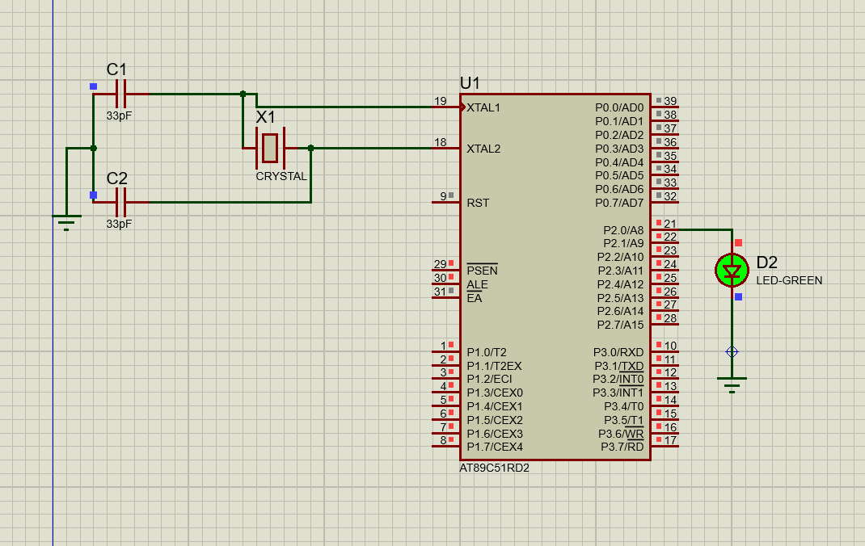
Experiment 1:

Source code:
ORG 0000H
UP:
SETB P2.0
ACALL DELAY
CLR P2.0
ACALL DELAY
SJMP UP
DELAY:
MOV R4,#35
H1:
MOV R3,#255
H2:
DJNZ R3,H2
DJNZ R4,H1
RET
END

